# Low Poly Generator 0.5.4 Manual

Designed by Panteleymonov Aleksandr 2017

## About

This is a collection of modeling techniques of geometric forms low polygon objects of different types. You can see all the possible variants of the types in the examples. There are no functions more detailed editing, you can use only the properties of the generator. You can use this script for Unity4 and Unity5.

## How to use

First you should know what kind of generator it is possible to simulate the necessary form.

* SimpleGenerator - designed for simple individual forms. May be available in the menu "Component/LowPolyGenerator/SimpleGenerator"
* TreeGenerator - designed for complex branched forms. May be available in the menu "Component/LowPolyGenerator/TreeGenerator"

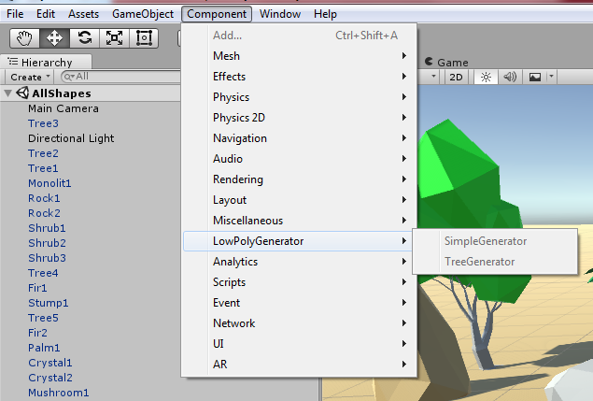

To view the main types of forms open scene "AllShapes". Maybe you can make something more using these generators. Now you need to choose one of the generators and apply it to an empty GameObject or you can use Prefab or load template on button “Loat Themplate”. If you try to load a template for the other generator it will have no effect. You can save your customized settings in an XML or create a new shape Prefab. If you remove the component of the generator the object will be the usual static form, but you will not be able to export this gameobject in a prefab, it needs save generated mesh to assert.

### Export gameObject to static Prefab

Every time a scene containing the generated object will load it will be rebuilt, this will reduce the amount of data but the scene may then be loaded for a long time until all objects are built. The next steps you need to perform to export an object.

Save Mesh to assert.

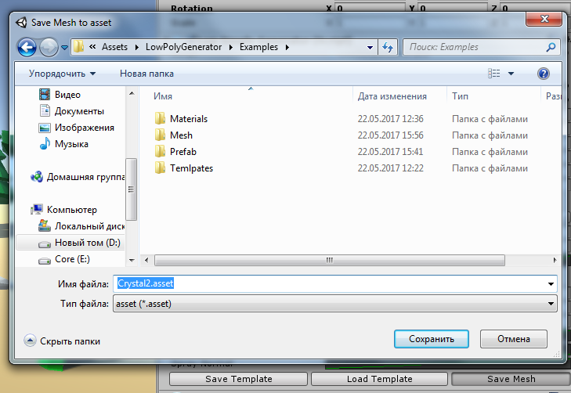

Remove Component of generator.

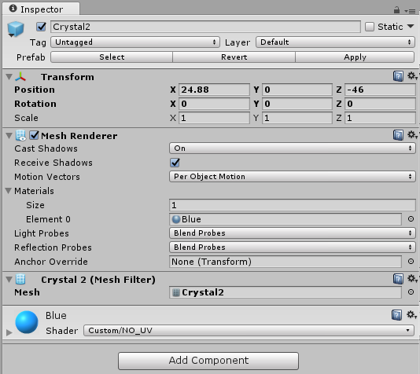

Now you can export gameObject ot prefab.

## SimpleGenerator

Now try to create a model with a simple generator in your own hands. You can see the auxiliary labels on every property But not all of them can explain their purpose because it is quite specific for different types of objects and may be completely different from the type of surface.

### **Global**

* Material – material for surface.
* Center – Allows aligning the base form.
* Noise Seed - the seed distribution of the noise.

### Box, Noise

This is the modifier applied to the sphere is built based on the icosahedron. Each of the modifier scaling the vertex have traped under his influence and aligns in the plane

Box uses 6 modifiers are similar to the sides of the cube.

* Force (SSS Mode Count) – specifies the number of times that the modifier will be applied to each side.

Noise uses multiple modifiers are located in a random direction.

* Count (SSS Mode Count) – specifies the number of modifiers.

Other options are the same effect on these types of surfaces.

* Radius (SSS Mod Radius) - sets the radius modifier.
* Curve (SSS Mod Curve) – the main function of the modifier.

 To distribute the vertices influenced by modifier radius

 will have no effect.

Features of global properties:

* Detail – count of faces equal 21 * pow(4, Detail).
* Box Size – scale of shape by x, y, z.
* Down Force - the modifier forms of subsidence.
* Noise Force – the impact of noise on the values of vertices.

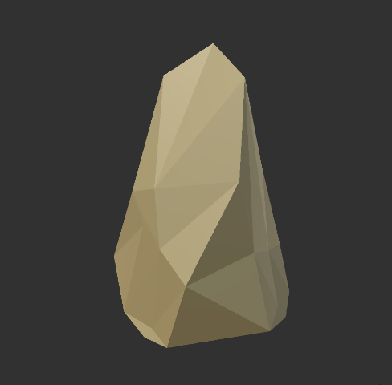 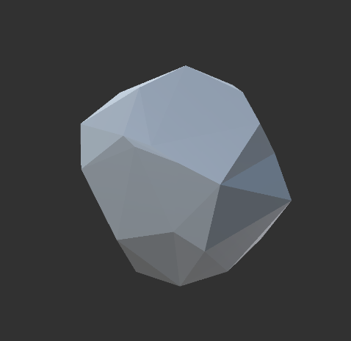

### Crystal

Surface properties of crystal shape:

* Face Segments (SSS Mode Count) – specifies the parts of faces.
* Thickness (SSS Mod Radius) – thickness of the shape.
* Thickness Per Segment (SSS Mod Curve) - specifies the thickness of the segments.

Features of global properties:

* Detail – count of segments.
* Size, Height, Head (Box Size) – x object scale, y – length, z – head length.
* Noise Force – the impact of noise on the values of vertices.

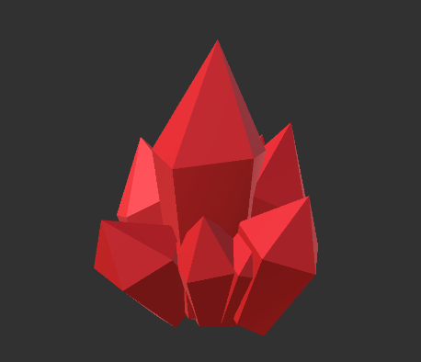 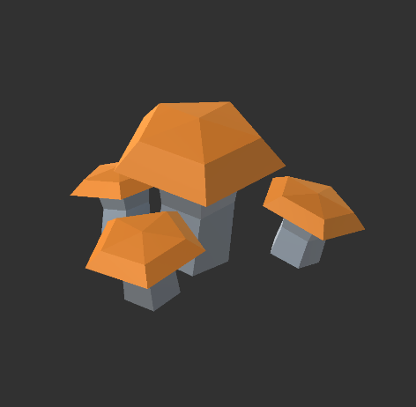 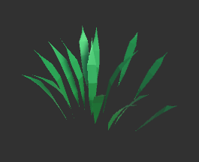

### Mushroom

Surface properties of mushroom shape:

* Face Segments (SSS Mode Count) – specifies the parts of faces.
* Radius (SSS Mod Radius) – radius of the head.
* Thickness (SSS Mod Curve) - specifies the thickness of the segments.

Features of global properties:

* Sub - material for surface head.
* Detail – count of segments.
* Size, Height, Head (Box Size) – x object scale, y – length trunk, z – head length.
* Noise Force – the impact of noise on the direction of the trunk segments.

### Grass

Surface properties of grass shape. Properties similar to crystal but allows you to bend and create objects similar to the tufts of grass or plants and scattered blades of grass.

Surface properties of grass shape:

* Face Segments (SSS Mode Count) – specifies the parts of faces.
* Thickness (SSS Mod Radius) – size of object.
* Thickness Per Segment (SSS Mod Curve) - specifies the thickness of the segments.

Features of global properties:

* Detail – count of segments.
* Length, Width, Twirl (Box Size) – x length, y – width, z – twirl.
* Noise Force – the impact of noise on the values of vertices.
* Down Force - sets the force of the random direction of the stem for each segment.

### Grow

Surface properties of plants shape. Properties similar to crystal but allows you to bend and create objects similar to the pumpkin or other fruit.

Surface properties of grow shape:

* Face Segments (SSS Mode Count) – specifies the parts of faces.
* Length (SSS Mod Radius) – length of object.
* Thickness Per Segment (SSS Mod Curve) - specifies the thickness of the segments.

Features of global properties:

* Detail – count of segments.
* Root, Head, Twirl (Box Size) – x size of root, y – size of head, z – twirl.
* Noise Force – the impact of noise on the values of vertices.
* Down Force - sets the force of the random direction of the stem for each segment.

### Curved Whirl

Forms a surface by rotating the curve around the axis.

Surface properties of grow shape:

* Face Segments (SSS Mode Count) – specifies the parts of faces.
* Thickness (SSS Mod Radius) – length of object.
* Radius (SSS Mod Curve) - specifies the radius of the segments.

Features of global properties:

* Detail – count of segments.
* Root, Head, Height (Box Size) – x offset of root, y – offset of head, z – height.
* Noise Force – the impact of noise on the direction of axis rotation.
* Down Force – offset of middle parts of segments by axis.

### Spray

This set of properties creates an aggregation of primitives.

* Spray Original – show the original primitive.
* Spray Count - the number of primitives.
* Spray Box - the area of distribution of the provisions of the primitives.
* Spay Seed - value given a sequence of random numbers to obtain the positions of the primitives.
* Spray Pos - the concentration values relative to the distance shapes the center.
* Spay Scale - scaling shapes in relation to distance from the center.
* Spray Normal - the orientation of the shapes relative to the distance from the center.

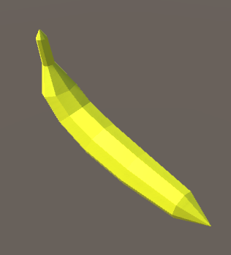 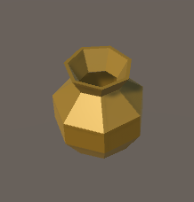 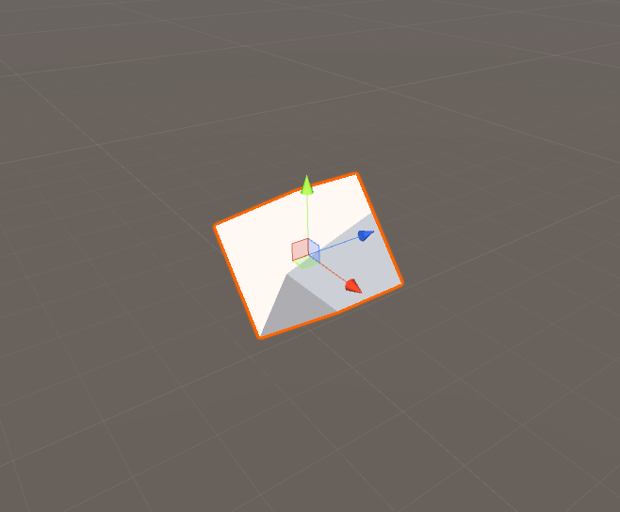 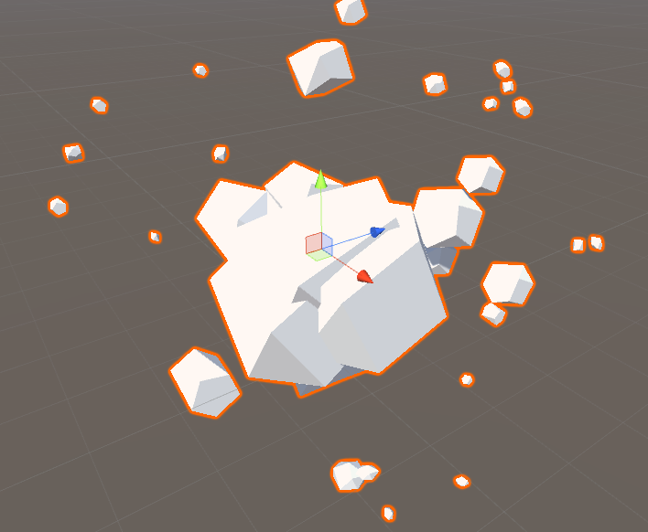

## Tree Generator

A more complex generator that allows you to create a branched object.

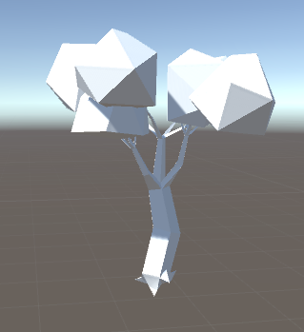 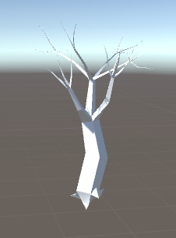 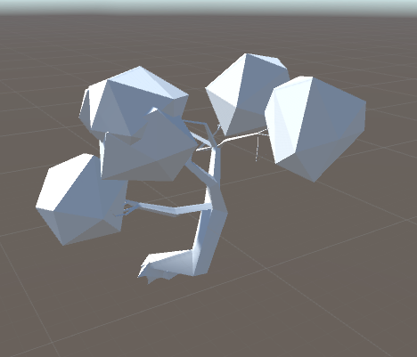

### Global

* Trunk Material - surface of trunk and branches
* Leaves Material - the surface of the leaves.
* Seed - sets the noise distribution function branches from trunk and root.
* Tree Noise Force - the impact of noise functions at the direction of the branches.
* Tree Noise Seed - noise sets the function direction of the branches.

### Trunk

* Trunk Iterations - the maximum level of inheritance growing branches

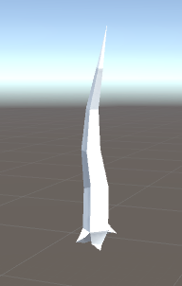 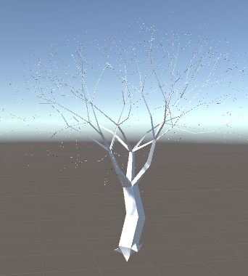 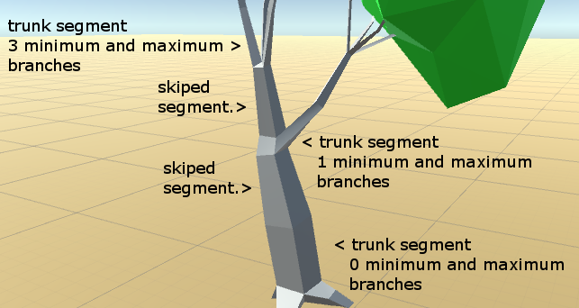

* Parts - the number of faces for the segment of the branch.
* Segments - the number of stages of the trunc.
* Skip Branch - period of stages which will grow the branches.
* Hide On Leaves - suppresses the generation of stages on which the leaves grow
* Trunk Segment Length - long each individual segment of the trunk from 1 to Segments as from 0 to 1
* Trunk Level Length - total length of branches of each level from 1 to Trunk Iterations as from 0 to 1
* Trunk Thickness - the thickness of the trunk for each individual segment from 1 to Segments as from 0 to 1.
* Max Branch - the maximum number of branches for each segment from 1 to Segments as from 0 to 1, equal Function value * Parts
* Min Branch - the minimum number of branches for each segment from 1 to Segments as from 0 to 1, equal Function value * Parts.
* Twirl - the slope of the branches for each segment from 1 to Segments as from 0 to 1.

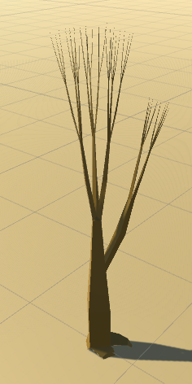 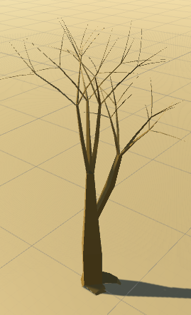 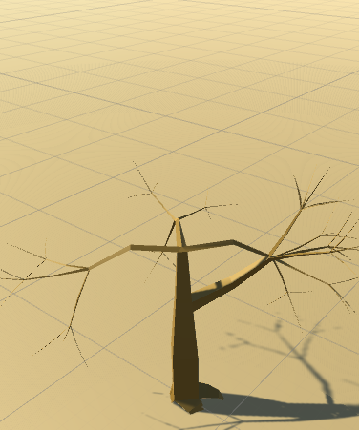

### Brunch

* Branch Segments - the number of stages of the branch
* Skip Sub Branch - period of stages which will grow the branches
* Branch Thickness - the thickness of the branch for each individual segment from 1 to Branch Segments as from 0 to 1.
* Max Sub Branch - the maximum number of branches for each segment from 1 to Segments as from 0 to 1, equal Function value * Parts.
* Min Sub Branch - the minimum number of branches for each segment from 1 to Segments as from 0 to 1, equal Function value * Parts.
* Inner Twirl - the slope of the branches for each segment from 1 to Segments as from 0 to 1.

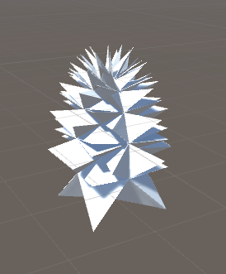 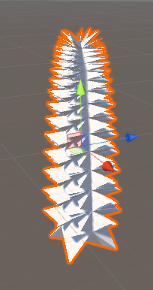 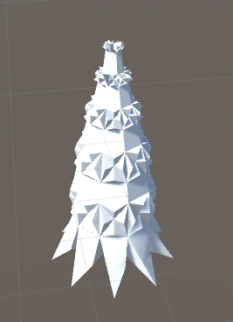

This generator does not allow to set the number of parts per segment for the branches. Depending on the end-this branch or the usual number of parts is equal to 3 or 4.

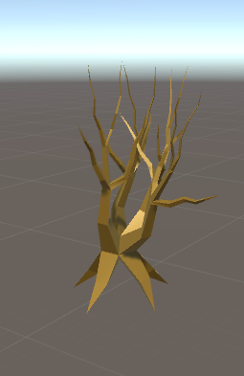 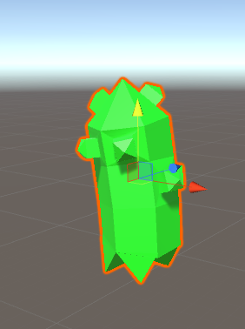

### Root

* Root Iterations - the maximum level of inheritance growing branches.
* Root Segments - the number of stages of the branch.
* Skip Root Branch - period of stages which will grow the branches
* Root Thickness - the thickness of the root;
* Root Segment Length – long each individual segment of the root from 1 to Segments as from 0 to 1.
* Root Level Length – total length of branches of each level from 1 to Trunk Iterations as from 0 to 1.
* Root Twirl - the slope of the branches for each segment from 1 to Root Segments as from 0 to 1.
* Root Noise Force - the impact of noise functions at the direction of the branches.
* Root Noise Seed - noise sets the function direction of the branches.

### Leaves

* Leaves Type - type of leaf shape.

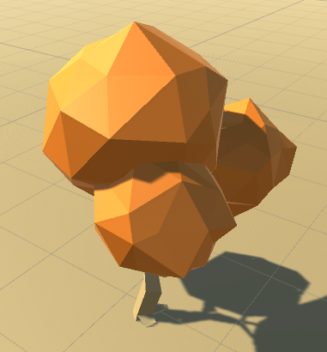 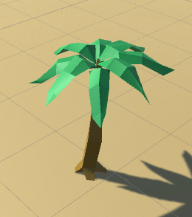 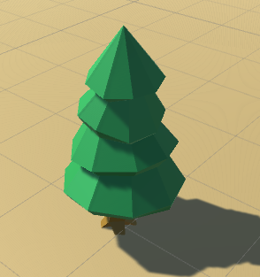

* Mesh - finished mesh for leaves.
* Start Iteration - the initial level branches which will grow leaves
* End Iteration - the final level with leaves
* Start Segment - the initial segment from which will grow the leaves
* Count Segment - the number of segments with leaves
* Leaves Scale - the base size of the shape
* Leaves Scale Curve - scale modifier each level of the branch from 1 to Iterations as from 0 to 1
* Leaves Scale Seg - scale modifier each individual segment of the branch from 1 to Segments as from 0 to 1
* Leaves Offset Curve - offset modifier each level of the branch from 1 to Iterations as from 0 to 1.
* Leaves Offset - baseline offset.
* Leaves Detail - the number of faces depends on the shape.
* Leaves Noise Force - the impact of noise on the values of vertices leaves.
* Leaves Noise Seed - the seed distribution of the noise leaves.

## Mesh Editor

This is an auxiliary tool with which you can correct the generated models. For the basis was taken tool editable mesh from 3D studio max. And also you can try to model your own. To access the tool, select Windows -> Low Poly Generator -> Mesh Editor. After that, you need to select a GameObject from the scene or create a new one using the "Create Empty" button. Now you can start editing using the button “Edit selected”. If the model does not have the desired grid, select it from the field “Object Mesh Filter” or button “Open Asset”. If you want to leave the old mesh, use "Save Asset" to save to another file, because the current one will be automatically changed.

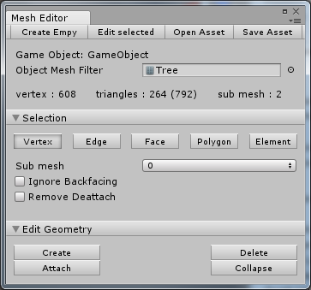 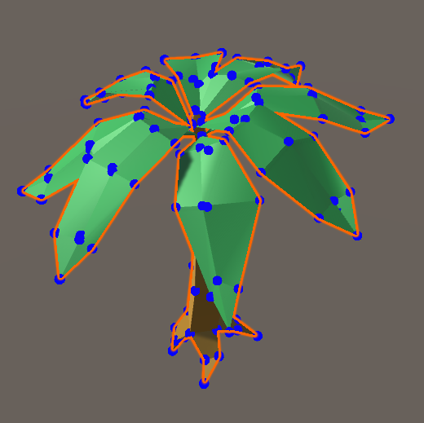

### Selection

You can edit the grid using different base elements:

* Vertex - are the vertices of the grid.
* Edge - are the edges of triangles.
* Face - are triangles.
* Polygon - are a group of triangles with common normals.
* Elements - operates on whole objects.

To select different items, hold Shift. To edit the selected elements, you can use the basic tool Unity move, rotating and scale.



Additional options will allow you to manage specific actions:

* Sub Mesh - used when creating or adding parts of a mesh.
* Ignore BackFacing - does not allow you to select elements located on the back of the mesh.
* Remove Deattach - removes the mesh detail when it was cut off, otherwise a copy is created.

### Edit Geometry

Depending on the type of items being edited, there may be a different set of tools that allows you to modify the mesh.

* Create - this button turns on and off the triangle creation mode. A new triangle will be created by three clicks on the scene, depending on whether it will be an empty space or the vertex will be created new or used by the selected one. A triangle will be added to the selected sub mesh or a new one is added.
* Delete - removes the selected item, depending on the type of element, several neighboring triangles can be deleted or only selected ones.
* Attach – This allows you to add another mesh of the game object. The mesh will be added completely to the selected sub mesh or the new sub meshes created will be the same.
* Deattach - the selected elements will be created as a separate game object. If "Remove Deattach" was set, then in the current mesh they will be deleted.
* Collapse - all selected elements will be deleted and united one vertex.
* Turn - rotates the selected edge between two adjacent triangles.
* Divide - allows you to split an edge into two chats creating additional triangles.
* Extrude - Extrudes the selected face at the specified height.
* Break - Separates the selected face from the surface.

### Surface Properties

After you edit or create a ready-made mesh model, you may need to edit the smoothing of the normals between faces. This works only when faces, polygons, or elements are selected.

* Smooth - the normal of the edges between the selected faces will be unified, and the faces will be merged into polygons.
* Faces - normal edges between the selected faces will have separate lighting, and all polygons will be divided into triangles.
* By angle - The normals will be divided or unified, depending on the angle between the faces. The faces with an angle less than the indicated are merged, the others are divided into triangles.

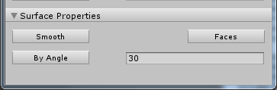

## Materials

Two surface shaders are included. A simple one that allows you to use textures without using UV coordinates. And a shader that generates color noise per vertex.

### NoiseColor

Materials created with this shader can cover the surface with noise in two ways. First set 3 specific colors, if it is not required you need to set all colors to the same. The second option is to set the strength (Noise Force) of a random color, the shades in this case are not contra-sized. You can also use these two approaches together.

